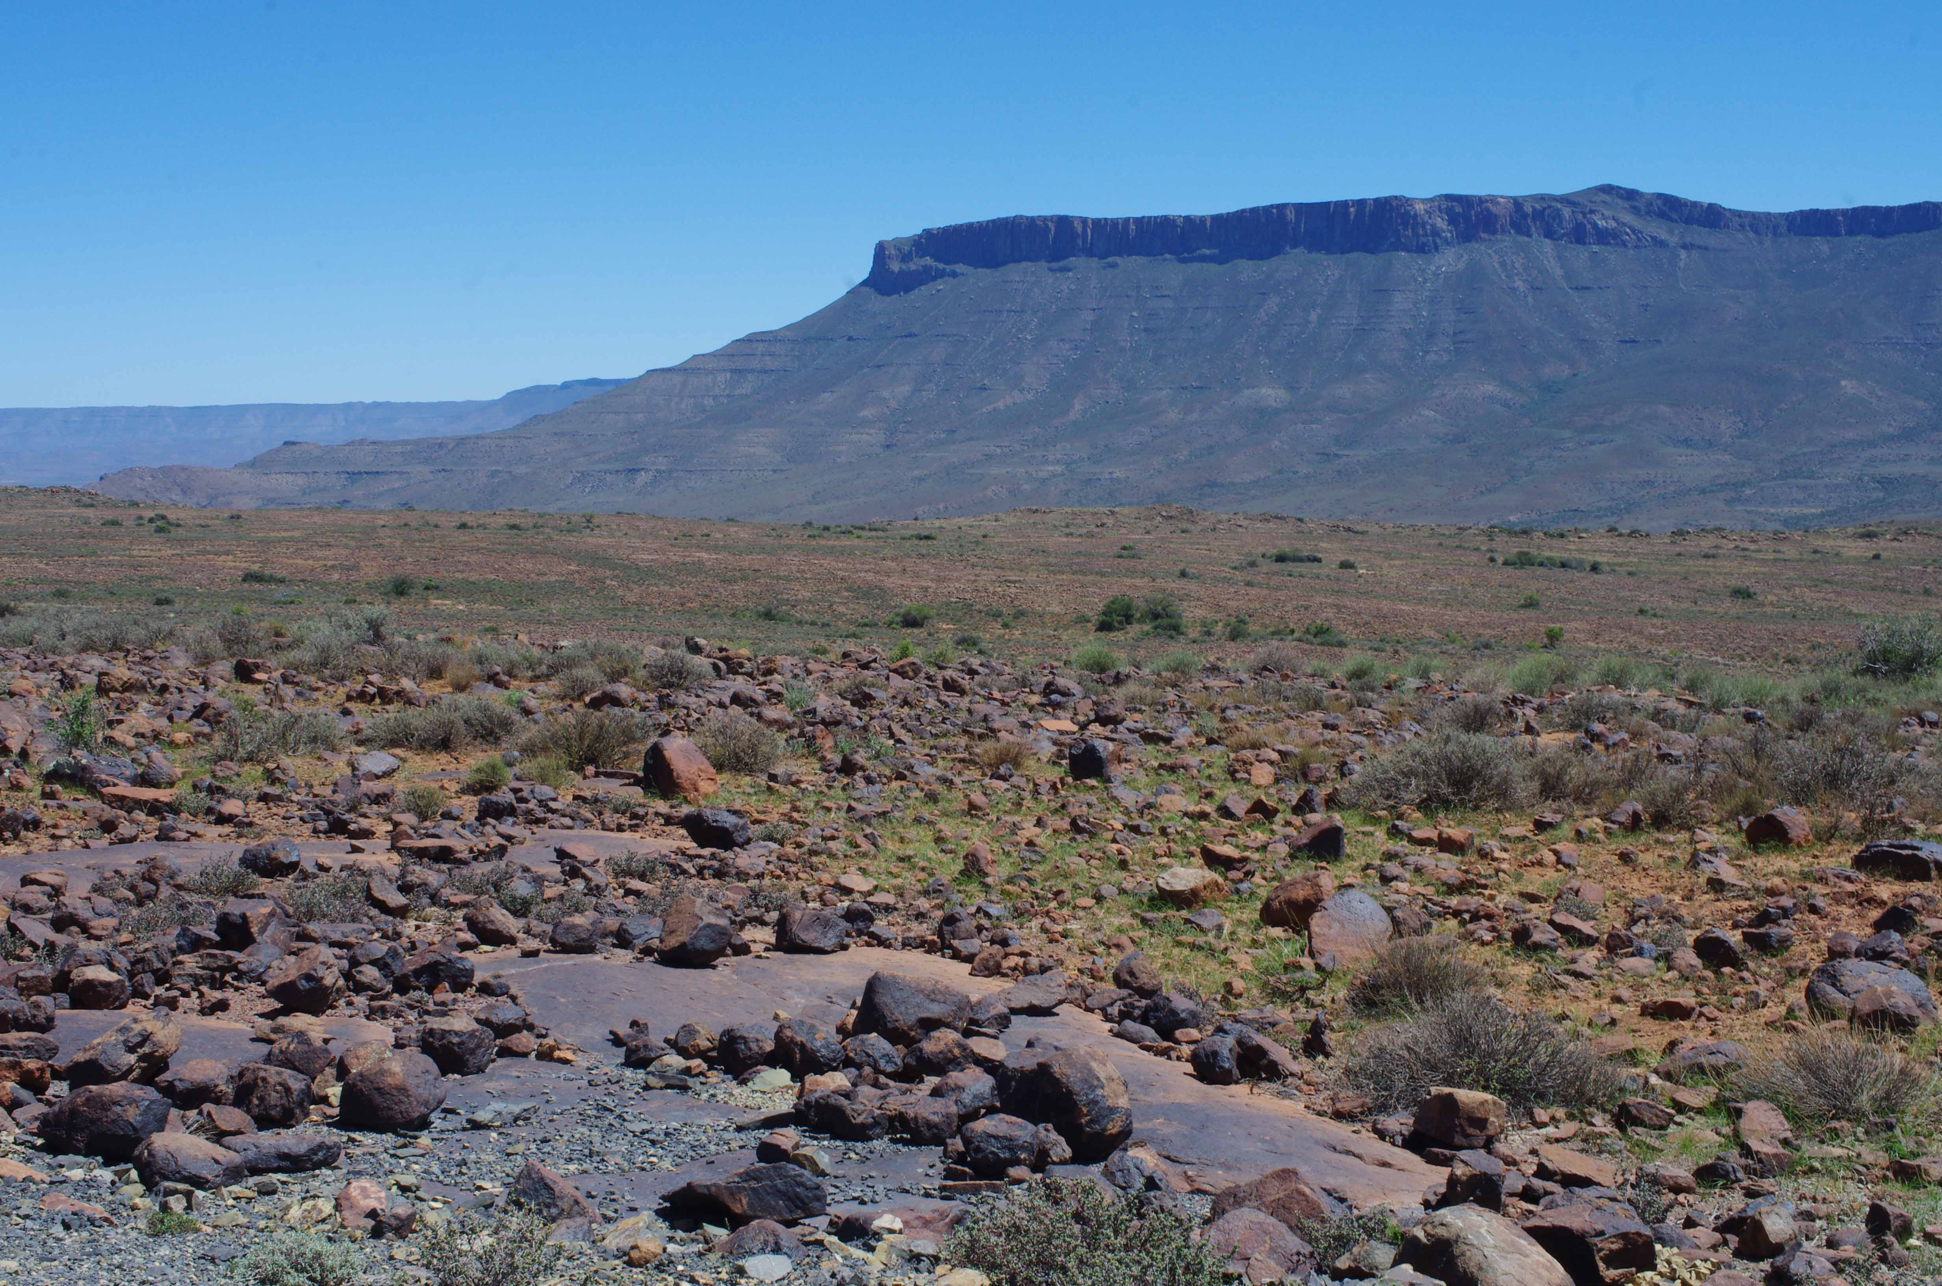
View of the Karoo National Park
Beaufort West
South Africa

The Century Rolls On

Dances by Ian Whitehead

