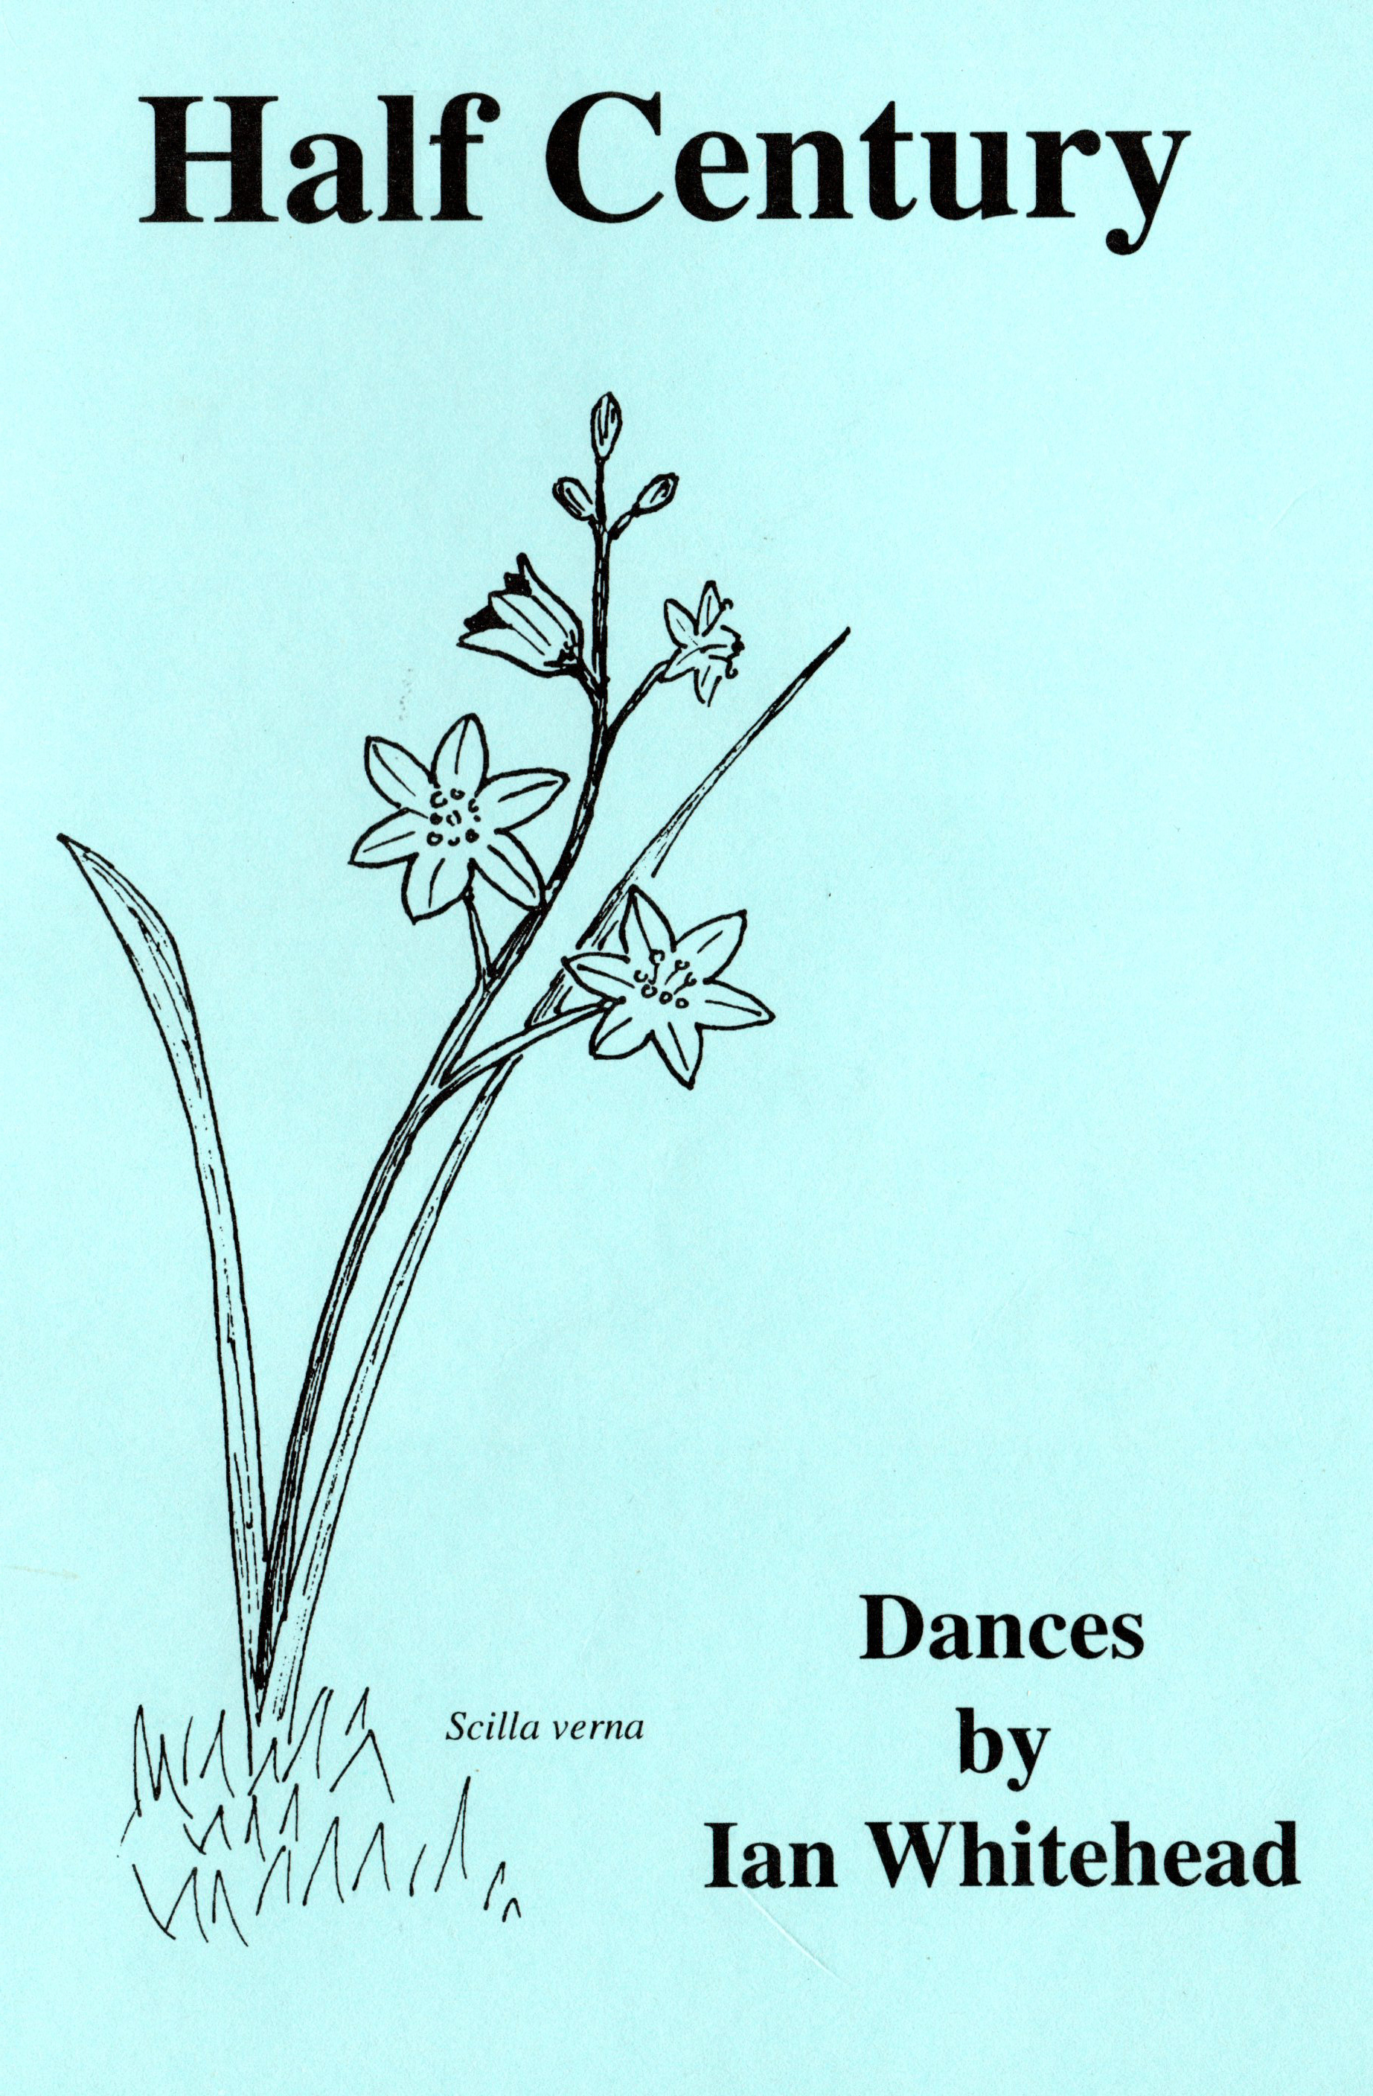
64, Sidney Road,
Rugby,
Warwickshire.
CV22 5LD
December 2017
01788-33-55-47

The original idea of publishing the first collection of my dances was to mark my 50th birthday in 1995, but it eventually emerged in 1997.
Now out of print, I have decided to put them all on line.

Ian R.Whitehead

IanWhitehead1@virginmedia.com

www.ianwhitehead.org

Contents:
Page Title Formation

3 A Grand New Square ..................... Square
3 Cowboy Square............................... Square
3 Hunt the Thimble............................ Square
4 Keep Moving.................................. Square
4 Tunnel of Love............................... Square
5 Nicely Does It................................. Square
5 Pant-y-Panel Square....................... Square
6 Square Yellow................................ Square
6 Ian’s Enigma 3 Couple Longways
6 Slot into Place 3 Couple Longways
7 The Eighth of May 4 Couple Longways
7 Nottingham 5-0 5 Couple Round
7 Half Century 6 Couple Longways
7 Along Comes Christmas Longways Improper
8 Belvoir Castle Longways Improper
8 Hose Special Becket Longways
8 Of Similar Ilk Longways Improper
8 The Squill Longways Improper
9 In Reverse Sicilian Circle
9 Goose Fair Sicilian Circle
9 Little Boxes Longways Set of Squares
A Grand New Square
Formation: Square for 4 couples.
Music: 4x 48 bar brisk reels/jigs.

A1 1-8 Sides face partners, grand square:
A2 1-8 Reverse, Heads join with corners to end in 2 lines of 4:
B1 1-4 In 4s, half right and left through:
5-8 All pass through; all U-turn back:
B2 1-4 Men swing the girl on their right (original corner):
5-8 Allemande left new corner:
C1 1-8 Grand chain all the way round the square:
C2 1-8 Promenade (new) partner all the way round the square:

Repeat the dance once more as above, then twice for heads face partners in A1 and the lines will be the other way at the end of A2.

Cowboy Square
Formation: Square for 4 couples.
Music: 4x 48 bar reels/jigs.

A1 1-8 All balance and swing partners:
A2 1-8 All join hands and circle left AND right:
B1 1-8 First couple lead a cowboy loop*:
B2 1-8 All four ladies chain across and back:
C1 1-4 Do-si-do partner:
5-8 Do-si-do corner:
C2 1-8 Promenade partner all the way home.

Each couple leads the cowboy loop in turn.

*
Keep the hands joined from the circle and the leading couple go across the set and under an arch made by the opposite couple. The leading couple then let go of each other and lead the rest round the outside to places, the couple making the arch turn under their own arch.

Hunt the Thimble
Formation: Square for 4 couples.
Music: 4x 48 bar steady reels/jigs.

A1 1-4 Head couples bow and take a short swing (once around):
5-8 Head couples circle left x1:
A2 1-4 Head couples circle right:
5-8 Head couples start to hunt the thimble – Head ladies in the lead go out
to the right between the sides. Go round the side lady with the head
men following their partners:
B1 1-4 Head ladies meet in the middle and do-si-do
AS
Head men take the lead and go out through the opposite sides:
5-8 Go round the side men and their partners follow. Head men meet
with a do-si-do (LEFT)
AS
Ladies get home and the men pass by left to home:
B2 1-8 Head couples star left and right:
C1 1-4 Allemande left corners like an allemande X:
5-8 Pass one girl and swing the next:
C2 1-8 Promenade this new partner to the man’s place, swing if time:

Repeat the dance for the heads leading etc. Then twice for the sides.

This dance is not for the faint-hearted! The main figure (and title of the dance) comes from an American Running Set movement.

Keep Moving
Formation: Square for 4 couples.
Music: 7x 32 bar American reels/jigs.

Chorus:
A1 1-8 Walk around the corner; see-saw your taw (partner)
A2 1-8 All circle left; ladies in, the men sashay:
B1 1-8 Allemande left the corner to an allemande thar*:
B2 1-8 Shoot the star and roll promenade your own partner home:
Figure:
A1 1-4 Head ladies chain half way:
5-8 Heads promenade three quarters of the way round the outside:
A2 1-4 Sides pass through, split the heads, go around one:
5-8 Two lines of four go forward / back:
B1 1-4 All pass through, all U-turn back:
5-8 Men half promenade the lady on the right across the lines:
(be very careful to do this BEFORE B2 starts)
B2 1-8 Promenade this new partner all the way round to the man’s place:

Chorus: 2x fig.heads:chorus: 2x fig.sides:chorus.

Tunnel of Love
Formation: Square for 4 couples.
Music: 7 x 32 bar steady jigs.

Chorus:
A1 1-4 Allemande left the corner:
5-8 Grand chain half way round:
A2 1-4 Do-si-do partner:
5-8 Start to circle left:
B1 1-4 Complete the circle all the way round:
5-8 Allemande left the corner:
B2 1-4 Grand chain half way to places:
5-8 Swing partner:
Figure:
A1 1-8 First couple face partner and pass by right and
go all the way round the set to places where they cross again and
go round two people to make two lines of three:
A2 1-4 Lines of three go forward / back:
5-8 Thoses lines go forward again and make a tunnel:
B1 1-4 Third couple lead up the tunnel:
5-8 Third couple swing
AS
The tunnel rotates half way round:
B2 1-4 Third couple down the tunnel again:
5-8 All swing partners
(sides are in opposite places but KEEP original numbers):

Chorus: Figure with 1s then 2s leading in A1 (all now half way round the set from original places). Chorus: Figure with 3s then 4s leading.

Nicely Does It
Formation: Square for 4 couples. .
Music: 7 x 32 bar reels/jigs.

Chorus:
A1 1-8 Allemande left the corner; allemande right your partner:
A2 1-4 Four ladies promenade inside the square (counter clockwise);
5-8 Swing partner:
B1 1-4 Allemande left the corner:
5-8 Weave the ring half way round:
B2 1-4 Do-si-do partner:
5-8 Promenade partner home:
Figure:
A1 1-4 Heads promenade half way round the outside
AS
Sides right and left through:
5-8 Sides square through four hands:
A2 1-4 Sides split the heads and go round one person:
5-8 Two lines of four go forward / back:
B1 1-2 Box the gnat with the opposite AND pull by that person:
3-6 Allemande left the corner:
7-8 Start to do-si-do partner –
B2 1-2 Finish the do-si-do:
3-4 Swing the corner (once around):
5-8 Promenade new partner home:

Chorus: 2 x figure with heads starting in A1: chorus: 2 x figure with sides leading in A1: chorus.

Pant-y-Panel Square
Formation: Square for 4 couples.
Music: 4 x 48 bar reels/jigs.
A1 1-4 First couple go forward / back into the middle of the set:
5-8 First man star left with 4s
AS
First lady stars right with 2s:
A2 1-4 First couple lead through the opposite couple;
Go around two to make lines of three:
5-8 Two lines of three go forward / back:
B1 1-4 Third couple go across the set; go around two:
5-8 Two lines of four go forward / back:
B2 1-4 Centre four people, star right x1:
5-8 Allemande left the corner x2:
C1 1-4 Do-si-do partner:
5-8 Start a grand chain:
C2 1-4 Complete the grand chain all the way:
5-8 Swing partner:

Repeat the dance with each couple leading in turn.

This was composed on a farm (Pant-y-Panel) near Dolgellau where I had many excellent holidays.

Square Yellow
Formation: Square for 4 couples.
Music: 32 + (4 x 48) + 32 bars

Opening chorus:
A1 1-8 All four ladies chain across and back:
A2 1-8 Promenade partner all the way round:
B1 1-8 Sides face partners, grand square:
B2 1-8 Reverse:

Figure:
A1 1-2 Allemande left the corner (4 steps) into –
3-8 All four ladie chain three quarters to their corners (same man!):
A2 1-4 Heads promenade half way and lead to the right:
5-8 Circle left in fours and the head men break to two lines of four:
B1 1-4 Lines go forward / back:
5-8 In fours, right and left through across the lines:
B2 1-4 All star through across the lines,
Outsides dive through AND pass through
(New outsides California twirl to face back):
5-6 All star through the one you meet:
7-8 Start to quare through three hands and courtesy turn the next:
C1 1-4 Complete this (like a square through2 then right and left through):
5-8 Star through (again)
Outsides dive through AND pass through
(New outsides California twirl to face back):
C2 1-8 Allemande left the corner INTO roll promenade half way:

Closing chorus:
A1 1-8 Sides face partners, grand square:
A2 1-8 Reverse:
B1 1-8 All four ladies chain across and back:
B2 1-8 Promenade partner all the way round.

Chorus: 2 x fig.heads: 2 x fig.sides: chorus.

Ian’s Enigma
Formation: 3 couple longways.
Music: 3 x 32 bar reels/jigs
A1 1-4 Middle couple lead up through the top and cast back to middle:
5-8 Middle couple lead through the bottom and cast back to place:
A2 1-4 Top two couples star right:
5-8 Middle couple two hand turn clockwise:
B1 1-4 Bottom two couples left hand star:
5-8 Middle couple two hand turn counter clockwise:
B2 1-4 Lines go forward / back:
5-8 Top couple lead down the centre to the bottom:

Slot into Place
Formation: 3 couple longways.
Music: 3 x 32 bar reels/jigs
A1 1-4 All join hands and circle left:
5-8 Circle right:
A2 1-4 Top two couples star left:
5-8 Bottom two couples star right:
B1 1-4 Balance to partner x2:
5-8 Swing partner:
B2 1-4 All half poussette partners – 1st man push then pull to middle place
AS
2nd and 3rd men pull then push:
5-8 All half poussette partners – 1st man pull then push to bottom place
AS
2nd and 3rd men push then pull:
(Take care not to rush the pousstting.)

The dance was composed in Denmark where a slot is a castle. I could not resist the play on words.

The Eighth of May
Formation: 4 couple longways, with 2s and 4s improper..
Music: 4 x 32 bar steady reels or jigs.

A1 1-4 Lines go forward / back:
5-8 Partners star through and set, in pairs facing up/down the set:
A2 1-8 Ladies chain there and back in those pairs up/down the set:
B1 1-2 In pairs, star left half way:
3-4 Centre four star right half way:
(Take care when finishing this star and going into the circle!)
5-8 All eight circle left half way:
B2 1-4 All face partners, pass through and all U-turn back to face in again:
5-8 Do-si-do partner:

Written for my parent’s Golden Wedding Anniversary on May 8th 1993.

Nottingham 5-0
Formation: Round for 5 couples.
Music: 5 x 48 bar steady Scottish reels.
A1 1-8 All five ladies weave the set, going in front of partners to start:
A2 1-4 All five ladies star right and stay in centre, facing out:
5-8 Set to partners x1 AND change places with a half left hand turn:
B1 1-8 All five men weave the set, going BEHIND corners to start:
The men end the weaving on the right of their partner into -
B2 1-4 All five men star right and stay in centre, facing out:
5-8 Set to partners x1 AND change places with a half left hand turn into -
C1 1-4 All five ladies chain as in Levi Jackson:
5-8 All five ladies chain as in Levi Jackson to their original corner:
C2 1-8 Promenade this new partner:

This was written to celebrate Nottingham Folk Dance Group’s 50th anniversary in September 1987.

Half Century
Formation: 6 couple longways, with 1s, 3s and 5s improper..
Music: 6 x 32 bar steady reels or jigs.
A1 1-4 Lines go forward / back:
5-8 Swing partners and face up / down the set in pairs:
A2 1-8 Ladies chain / back in those pairs:
B1 1-2 Centre four star left half way:
3-4 Those same dancers star right half way with the next couples:
(4 + 2; 5 + 3)
5-6 Star left half way on the ends:
7-8 All turn single right and face ‘corner’ dancer:
B2 1-4 All do-si-do that corner dancer:
5-8 All do-si-do partner:
Written to celebrate my 50th birthday in October 1995.

Along Comes Christmas
Formation: Longways duple minor , 2s improper.
Music: 32 bar steady sing-along tunes.

A1 1-4 Face partners, right and left through, into -
5-8 Star left all the way, end facing neighbour on the side of the set:
A2 1-4 With neighbour, LEFT and RIGHT through, into –
5-8 Star right to places:
B1 1-8 Ladies chain across the set and back:
B2 1-4 Half promenade neighbour across the set:
5-8 All pass through across the set and,
turning towards new neighbour, face in again:

The dance was devised so that everyone does the same moves and so that dancers can hold hands with one another for as long as possible.

Belvoir Castle
Formation: Longways duple minor , 1s improper.
Music: 32 bar reels/jigs.
A1 1-4 Do-si-do neighbour right shoulder up/down the line:
5-8 Slide through*; balance forward / back in long lines:
A2 1-4 Men reverse flutterwheel**:
5-8 Pass through; wheel left with the lady on the right
(One progression, ends fold round to face up/down the set)
B1 1-4 With the new couple, right and left through across the set:
5-8 Ladies chain across in the same fours:
B2 1-4 Do-si-do partner LEFT shoulder:
5-8 Star LEFT and look for the NEXT couple:
(Second progression.)
* Slide through – pass neighbour right and then men turn 1/4 right as ladies turn 1/4 left.

** Men reverse flutter wheel – men give left hands and turn half way, keep hold and take the lady standin there by her left hand and all 4 dancers go half way round the set. The men will have done a complete turn, ladies will have crossed over.

Composed for Nottingham Folk Dance Groups Belvoir Assemblies held at Hose in the Vale of Belvoir.

Hose Special
Formation: Becket longways.
Music: 32 bar steady reels/jigs.

A1 1-4 Balance forward / back to the opposite AND star through:
5-8 Do-si-do partner:
A2 1-4 Touch a quarter right* to a tidal wave; rock forward / back:
5-8 Box circulate to tidal waves again; rock the wave:
B1 1-4 Box circulate AND quick swing with partner:
5-8 Long lines go forward / back:
B2 1-4 Diagonally right, if possible, right and left through:
5-8 Half promenade partners across the set: (CAREFUL!!)

Of Similar Ilk
Formation: Longways duple minor , 2s improper.
Music: 32 bar steady reels/jigs.

A1 1-4 Right and left through across the set:
5-8 Ladies chain across:
A2 1-4 As couples, go forward – then fall back 1/4 of the way round:
(Still facing the same couple but up/down the set, 1s facing down.)
5-8 Half promenade partner, 1s are now facing up:
B1 1-8 Ladies chain there and back up/down the set:
B2 1-4 Star left with original couple:
5-8 Star right the next, keeping hold of partners right hand to start again:

The Squill
Formation: Longways duple minor , 1s improper.
Music: 32 bar reels/jigs.

A1 1-4 Do-si-do neighbours:
5-8 Pass through and swing the next to face down in a line of four:
A2 1-4 Line of four lead down the set
5-8 Turn alone and lead back up:
B1 1-4 Ends fold*; star through up/down the set:
(Don’t rush into this phrase.)
5-8 Ladies chain across the set:
B2 1-4 Ladies chain back across the set:
5-8 Star LEFT in fours and look for the new neighbour:

*Ends fold – the centres stay facing up and the ends fold round to face down the set. Not quite like a bend the line.

In Reverse
Formation: Sicilian circle.
Music: 32 bars steady reels.

A1 1-4 Circle left with the opposite couple:
5-8 Do-si-do the opposite dancer:
A2 1-4 Circle right in the same fours:
5-8 Do-si-do partners and stay facing them:
B1 1-6 With the couple who were BEHIND you at the start of the dance –
Square through four hands (STEADY) to face original couple:
7-8 Star right with them just half way:
B2 1-4 Balance x2 to partners:
5-8 Swing partners and face the original direction:

Goose Fair
Formation: Sicilian Circle.
Music: 32 bar steady reels or jigs.
A1 1-4 Go forward / back to the opposite couple:
5-8 Promenade round this couple
to face the couple who were behind you at the start:
A2 1-8 As in A1 1-8 to get back to places:
B1 1-8 Ladies chain across / back:
B2 1-4 Go forward / back to original couple:
5-8 Go out to the right as a couple and onto the next (NO RUSH):

Little Boxes
Formation: Longways set of several square sets.
Music: 32 bar steady reels.

A1 1-8 In each square, all four ladies chain across / back:
A2 1-6 In each square, all promenade partner three quarters of the way round:
7-8 All balance x1:
B1 1-4 Those in head positions, star LEFT and then -
5-8 If possible, star right with a couple from the next square
AND stay facing them:
B2 1-4 If possible, those in head positions do-si-do the opposite dancer
AS
Rest do-si-do partners:
5-8 If possible, those in head positions pass through
AND two hand turn half way in a new square

AS
The rest swing partners and form the new squares:

Written before I had even heard of grid squares, so this is a simple one – it could be done as a grid by alternating whether it is heads or sides that star and progress!

